VISUALIZING BIOMOLECULAR DYNAMICS
An Educational Co-development Experience for High School Educators
Turn complex mathematical and biophysical simulations into engaging digital visualization experiences for your classroom.
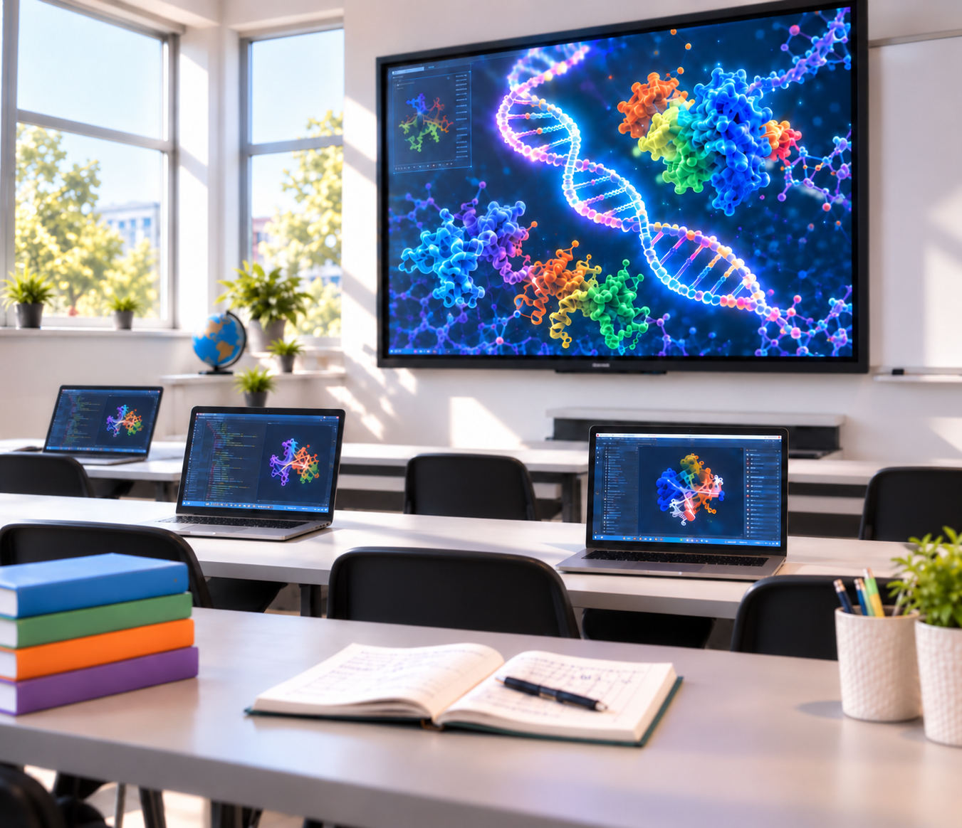
GRADE LEVEL  High School (Grades 9–12) | DATES  June 14 – July 24, 2027 | LOCATION  NC State University  Raleigh, NC

Program Description
Rapid advances in computing, artificial intelligence, and data-driven science are transforming both scientific research and everyday life. These developments create an exciting opportunity to bring computational thinking into high school classrooms and help prepare students for future study and careers in STEM.
Our research group at NC State University develops computational and data-driven methods to predict and simulate biomolecular dynamics. These simulations allow us to visualize how molecular "nanomachines" function inside cells, including processes such as protein folding, viral entry, and membrane dynamics, and to connect mathematical and physical concepts with biological function.
Many of these visualizations are created through coding and scripting, transforming abstract equations and simulation data into vivid, interactive experiences. Modern tools, including virtual reality, can make molecular structures and motions even more intuitive and engaging.
This creates a unique opportunity to help students learn computational skills while seeing, firsthand, how coding, mathematics, physics, and biology can come together to answer real scientific questions.
To bring these ideas into high school education, we are launching a Digital Technologies Academy (DTA) for high school students and inviting high school teachers to partner with us in co-developing classroom-ready educational modules. Teacher perspectives will be central to ensuring that the activities are engaging, accessible, and aligned with real classroom needs.
THROUGH THIS PAID 4-WEEK EXPERIENCE, YOU WILL:
- Gain hands-on training in computational programming and molecular visualization tools to create biomolecular animations and interactive demonstrations
- Explore modern AI tools for biomolecular modeling and visualization
- Co-design hands-on student projects that introduce foundational skills in coding, data-driven science, and biomolecular visualization
- Co-develop teaching materials that can be adapted for use in your own courses and school curriculum
By the end of the program, you will have practical experience, adaptable teaching materials, and a direct connection to an active university research environment that you can bring back to your students.

Program Overview
This 4-week paid fellowship is designed to immerse participating teachers in a university research environment while supporting the development of meaningful, classroom-ready instructional materials. We plan to invite up to two teachers to work with our group and help develop a pilot Digital Technologies Academy (DTA) for high school students, where the co-developed activities will later be tested and refined.
PHASE 1  Lab Immersion  Weeks 1–2 • June 14–25, 2027  - Location: Department of Physics and Astronomy, College of Sciences, NC State University, Raleigh, NC  - Schedule: Flexible schedule totaling approximately 20 hours per week  - Learn introductory coding and molecular visualization skills using lab-developed tutorials and guided activities.  - Explore and test visualization tools developed by our research group.  - Discuss how computational thinking and digital tools can help prepare high school students for college-level STEM learning and future careers. | PHASE 2  Teaching Materials Development  Weeks 3–4 • July 12–24, 2027  - Location: Department of Physics and Astronomy, College of Sciences, NC State University, Raleigh, NC  - Schedule: Flexible schedule totaling approximately 20 hours per week  - Co-develop educational modules for the Digital Technologies Academy (DTA) for high school students.  - Adapt selected activities and materials for use in your own courses and school curriculum.

Deliverables & Outcomes
By the end of the summer experience, you will have developed educational resources that can be used or adapted for your classroom, including:
- Introductory tutorials for teaching basic coding and computational thinking skills
- A collection of examples and activities for visualizing biomolecular structures and functions on a computer
- Enhanced biomolecular visualization demonstrations, including opportunities to explore virtual reality tools
- Potential opportunities to co-author science education publications (for example, in the Journal of Chemical Education or Physics Education) and to present the educational work
- Continued collaboration and support after the summer experience, including potential opportunities for selected teacher participants to return as instructors for future DTA workshops
PARTICIPANT SUPPORT  - Stipend: $2,000 total ($500 per week).  - Fellowships available: Up to 2 positions for Summer 2027. | WHO SHOULD APPLY?  We welcome high school science teachers who are interested in computational programming, visualization, and bringing authentic research experiences into their classrooms. No prior background in biology is required. Curiosity, enthusiasm for learning new tools, and an interest in preparing students for a technology-rich future are most important. Some prior exposure to programming or computational coursework is preferred, but extensive coding experience is not required.

How to Apply
APPLICATION DEADLINE: APRIL 1, 2027
Please submit the following materials as a single PDF to Xingcheng_Lin@ncsu.edu
1 | Resume (1–2 pages)  A brief summary of your education, teaching experience, and any relevant computational or programming experience.

2 | Statement of Interest (maximum 500 words)  Please briefly address:  - Why this program? What interests you about this opportunity and working with our research group?  - Your goals: What skills, experiences, or resources do you hope to gain from the fellowship?  - Classroom impact: How do you envision using this experience to engage your students or enhance your teaching?

3 | Course Context Summary  Please provide a brief overview of the courses you currently teach or expect to teach next year. For each course, include:  - Course title and grade level  - Approximate number of students  - Key learning objectives or standards covered

4 | Letter of Support (optional but encouraged)  A brief note from a school administrator (such as a principal or department head) acknowledging your participation and supporting the possible implementation of new curriculum materials in your classroom.

Questions or want to learn more?
Xingcheng Lin, Ph.D.
Email: Xingcheng_Lin@ncsu.edu
Research Group: https://linresearchgroup-ncsu.github.io/

